How to add 3rd party libraries to tomcat (server side only!)

The war created by your project can hold various 3rd parties that you would like to use during your application. (3rd party runs from Gson.jar up to your own game engine jar file, or any other 3rd party you would like to use that comes, naturally, as a jar file).

The 3rd party(s) must lie **inside** the war, so that when they will be deployed in tomcat, tomcat will also have that 3rd party available and will be able to play it as needed.

According to the java EE spec, the war contains special folder that needs to hold these jars.

The folder 'lib' (must be called like that), lies within the folder 'WEB-INF' (must be called like that), near the folder 'classes' (guess what: must be called like that).

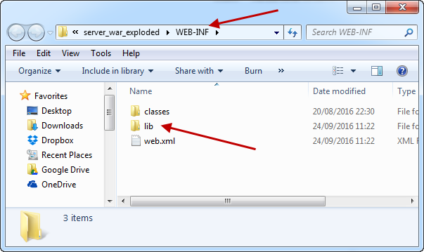

This folder will hold all your 3rd party jars. Tomcat knows that (actually expect that) and will know where to search for them and make them available for your use.

When you define the war structure (in intelij), you can also add to it any content you would like, in particular the content of the lib folder.

First you will need to add the third party as a dependency in the module definition itself:

Go to module setting (ctrl + alt + shift + s) and select 'modules'. Select the relevant module, and go to 'Dependencies' tab. Press the green '+' sign and select the 3rd party you would like to add (in this case gson.jar)

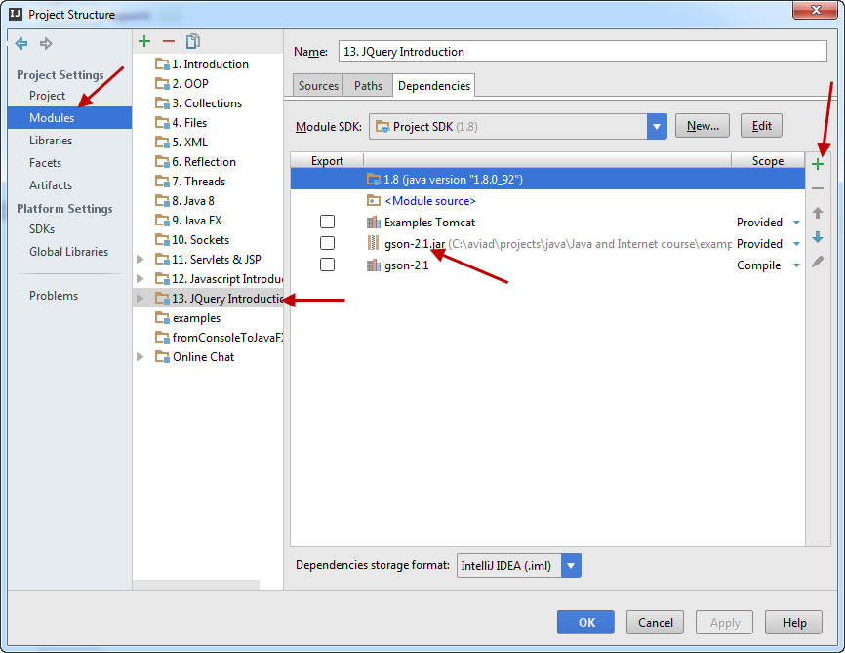

Second, you need to also include this 3rd party in the generated war.

select 'artifacts'. Select the relevant war artifact.

Make sure that at the correct folder you have the specified folder 'lib' and within you have the relevant 3rd parties you would like to consume.

If it does not exist, create it and add to it the relevant jars using the toolbar buttons:

